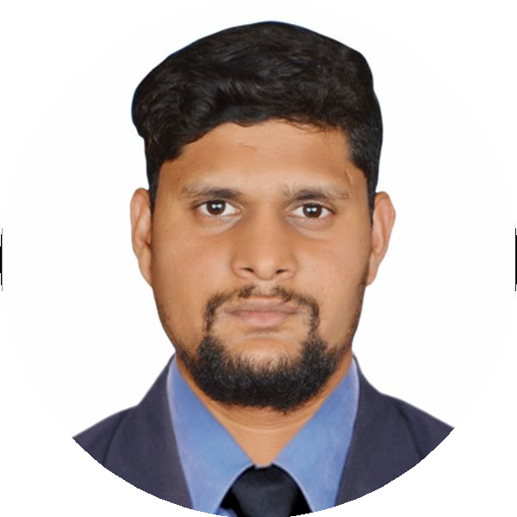
Shadab Khan
Technical Lead

+91-9527663992
khanshadab3130@gmail.com

https://linkedin.com/in/shadab-khan-827b82b2

Pune, Maharashtra, 411048 Nationality

SUMMARY

I have over 9 years of expertise writing server-side components with J2EE technologies and Java frameworks. I am well-versed in Object-Oriented Programming ideas and have developed commercial apps utilizing Java, JDBC, JSP, Spring Framework, Docker,
Kubernetes, and cloud platforms (AWS, Google Cloud). I'm a self-motivated, quick learner, and productive team player with a positive mindset.

Demonstrated leadership and mentoring in developing high-performance architectures with measurable project impact. Designed and deployed scalable microservices, ensuring robust API design and management.
Focused on delivering strategic technical solutions that enhance overall system performance.

EXPERIENCE

Technical Lead

Synechron Technologies Pvt Ltd
06/2021 - Present Pune
- Successfully directed all aspects of application design, development, and deployment.
- Constructed microservices that improved modularity within the application.
- Created REST API to augment overall application functionality.
- Oversaw team of 10, managing task assignments and tracking progress diligently.
- Engaged with customers to ensure precise capture of project requirements.
- Resolved production issues raised by clients through systematic troubleshooting.
- Developed effective database queries to streamline data retrieval processes.
- Delivered technical guidance and support to developers, optimizing team performance.

Java Developer

Persistent System Ltd
12/2020 - 06/2021 Nagpur
- Collected comprehensive customer requirements to inform project development.
- Analysing user requirements and transform them into technical specification to design and develop high quality, scalable java applications.
- Developed Microservices for all modules
- Providing ongoing maintenance for existing applications, troubleshooting issues, and implementing updates or enhancements.
- Working closely with other developers, project manager, designers and stakeholders to ensure project meet their functional requirements and business goals
- Resolving the production issues identified by the client users.
- optimizing applications, identifying bottlenecks, and implementing solutions to improve performance and scalability.
- Transformed user specifications into technical guidelines for scalable Java application design

Java Developer

Finoux solution Pvt Ltd
03/2019 - 12/2020 Mumbai

Java Developer

Puratech Solution (India) Pvt Ltd
09/2016 - 11/2018 Mumbai

EDUCATION

Bachelor Of Engineering - Information Technology

Gurunanak Institutions, Nagpur University
01/2012 - 01/2015 Nagpur, Maharashtra

EDUCATION

Diploma in Engineering

MSBTE
07/2009 - 08/2012 Mumbai, India

H.S.C

Amravati Board
07/2008 - 06/2009 Yavatmāl, India

KEY ACHIEVEMENTS

9 Awards
- Lead a team of ten people in the successful delivery of a complex microservices application.
- Designed and implemented a new microservices
architecture for critical application, improving system scalability and maintanability.
- I got star employee award twice in my current organisation.

LANGUAGES
English  Native |  | Hindi  Native |  |  | Marathi  Proficient
Urdu
Native
SKILLS
ACTIVEMQ Ansible | Apache | Apache Tomcat | AWS | C/C++ | Docker DSL Git HTML IBM

Java Java EE Java Spring JavaScript JDBC Jenkins JMS JSP Kubernetes Linux
PostgreSQL REST Servlets Soap SpringBoot Terraform Tomcat Web Logic XML

Hibernate Microservices Gmail AWS Lamda function AWS S3 AWS Runner Elastic Beanstalk
Ec2 instance Solace Messaging Queue

PROJECTS

RRCP
06/2023 - Present
Project# 1. June 2023 to present

Title: RRCP – Regulatory Reporting & Control Platform.
Environment: JDK 1.8, Spring Boot, Oracle, JavaScript, REST API, Microservices, Jenkins, Ansible, JMS, Git, Docker, K8S, AWS (S3, EC2, Elastic Beanstalk, EKS, RDS, CloudWatch & AWS Lambda).
Team Size: 10 Role: Developer Description:
I contributed to the development of the RRCP application, utilizing cutting-edge technologies such as Spring Boot, microservices, REST API, and Oracle for database management. The architecture includes a Data Service Layer (DSL) platform, with services such as Acquisition Manager, Delivery Service, Adapter Service, and Feedback Service deployed on the Internal Kubernetes Platform (IKP).
Communication between services is facilitated through Solace MQ.
The system handles various types of PTS sources, including XFOS, MARTINI, HTDE, and more. Trade files are received from the DSL
source via MQ, processed, and subjected to business logic to generate output XML, which is then transmitted to the DTCC system. All files undergo validation at DTCC, and upon compliance with the schema, a response is sent back to our Feedback Service. This service, in turn, publishes the response to the notification service, indicating whether the response is an acknowledgment (ACK) or a negative acknowledgment (NACK).
I played a key role in this project, contributing to the successful implementation of the system.

Project# 2: June 2021 to June 2023
Title: SFTR - Securities Finance & Trade Reporting.
Environment: JDK 1.8, Spring Boot, Oracle, JavaScript, Rest API, Microservices, Jenkins, Ansible, JMS, Git, Docker & Kubernetes, AWS(S3, EC2, Elastic Beanstalk, EKS, RDS, Cloudwatch & AWS Lambda).
Team size: 6 Role: Developer Description:
During the project duration from June 2021 to June 2023, our team utilized cutting-edge technologies such as Spring Boot,
microservices, RESTful APIs, and Oracle database to develop the SFTR application. The platform consisted of a robust Data Service
Layer (DSL), with all services including Acquisition Manager, Delivery Service, Adapter Service, and Feedback Service deployed on the Internal Kubernetes Platform (IKP). This enabled us to ensure seamless and efficient operations.

Project# 3
Title: PFM(Personal Finance Manager)
Environment: JDK 1.8, Spring boot, Oracle, JavaScript, Rest api and Tomcat Server. Team size: 5
Role: Developer Description:
We developed the PFM application using Spring boot, Java 8, and REST API. This application allows users to invest in a mutual fund and offers modules for investing, redeeming, SIP, and SWP. Users can log in to the application through their mobile or desktop to view their investments on the dashboard. They can also invest and redeem the amount as per their needs.

Responsibilities:
- Interacting with Customer to understand requirements
- Developed Microservices for all modules.
- Conduct code review, ensure adherence to coding standards and implement best practices to maintain code quality.
- Identify, troubleshoot and resolve technical issues and bugs within applications.
- Stay updated with new java technologies, frameworks, and industry trends to incorporate innovative solutions.
- Develop and maintain technical documentation for applications and systems.
- Ensure smooth coordination within the development teamand with other teams involved in the project.
- Resolving the production issues reported by the client users
- Write database queries for fetching data from Database
- Created a utilities to build code in a fast and efficient.
- Enhance the code to overcome duplicate task
- Enhance the development by using th utility to generate FTL template along with feature files.
- What was a successful outcome of your work? (e.g. Raised $3,000 for the charity)

